**Sentiment Analysis using Social Media data**

**Sentiment Data**

* Unstructured data on opinions, emotions and attitudes contained in sources like social media, blogs, online product reviews and customer support interactions

**Potential Uses of Sentiment Data**

Organizations use sentiment analysis to understand how the public feels about something at a particular moment in time, and also to track how those opinions change over time. An enterprise may analyse sentiment about:

* **A product** – For example, does the target segment understand and appreciate messaging around a product launch? What products do visitors tend to buy together, and what are they most likely to buy in the future
* **A service** – For example, a hotel or restaurant can look into its locations with particularly strong or poor service.
* **Competitors** – In what areas do people see our company as better than (or weaker than) our competition?
* **Reputation** – What does the public really think about our company? Is our reputation positive or negative?

**Input Data**

You can download a set of sample Twitter data contained in a compressed (.zip) folder which was collected from one following way.

1. The Twitter data was obtained using Flume. Flume can be used as a log aggregator, collecting log data from many diverse sources and moving it to a centralized data store. In this case, Flume was used to capture the Twitter stream data, which we can now load into the Hadoop Distributed File System (HFDS).

2. We can also use R-Hadoop integration and connect R with Twitter to extract the tweets data and upload as json files

3. We can also collect the reviews from any other social media website using WebCrawler's

**Expected Output:**

In order to optimize your website and convert more visits into sales and revenue. To refine and visualize website sentiment data, we will:

* Download and extract the sentiment tutorial files.
* Twitter data in a tabular format with sentiment ratings
* How sentiment varies by country and review the sentiment data for the United States

**Refining the raw tweets and creating tables accordingly**

Create the tables of raw tweets, dictionary and time_zone_map

----------------raw_tweets_table-----------------------------------------------------------

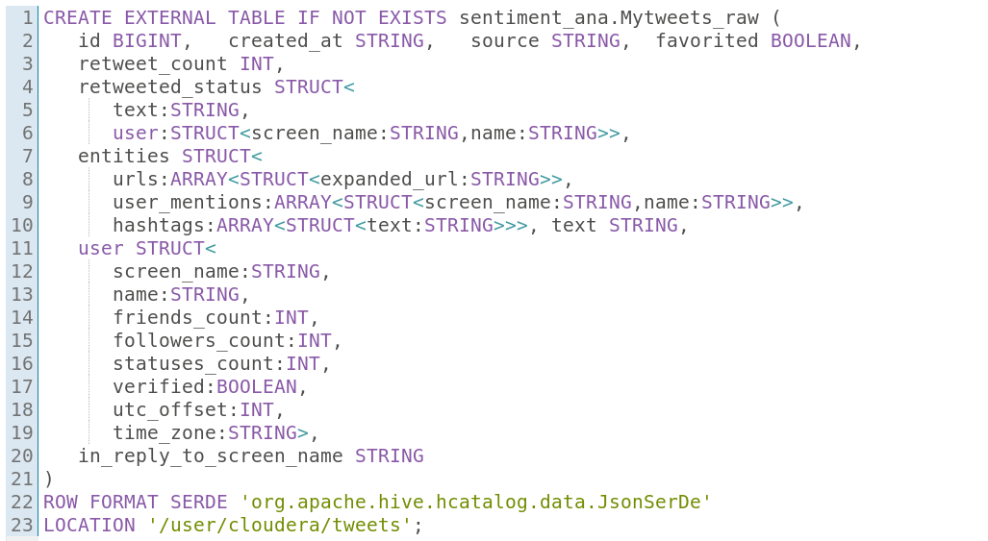

-------------dictionart_table-----------------------------------------------------------------------

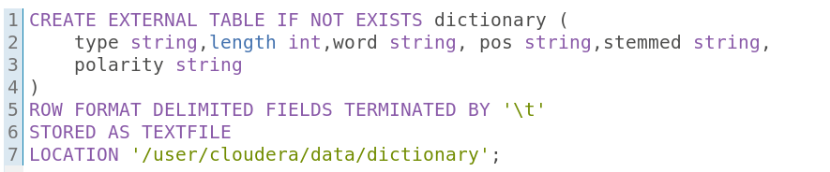

----------------------time_zone_map_table-------------------------------------------------

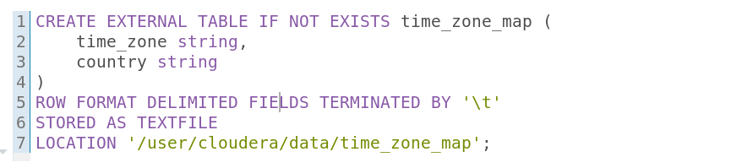

---------------------tweets_simpe_table--------------------------------------------------------

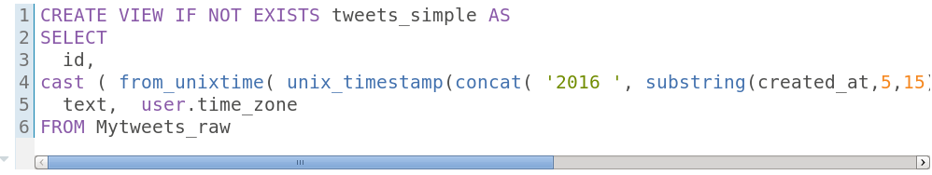

--------------------tweets_clean table------------------------------------------------------------

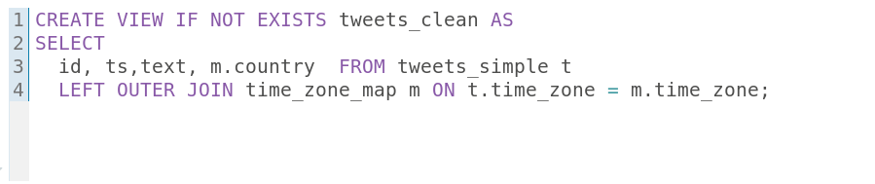

**Visualisation using Tableau :-**

